

Excel Assignment - 9

1. **What are the different margins options, and do we adjust the margins of the excel worksheet?**

Answer – Margins comes into picture while giving a print of the worksheet, margins mean the space between the worksheet information and the blank space present on Left, Right, Top, Bottom of the page, margin options are Normal, Wide, Narrow and we can also customize the margins by increasing and decreasing the length of margins.

1. **Set a background for your table created.**

Answer - Two ways of setting background one is set background for the worksheet which also covers the table. Second way is to fill the desired color in the table.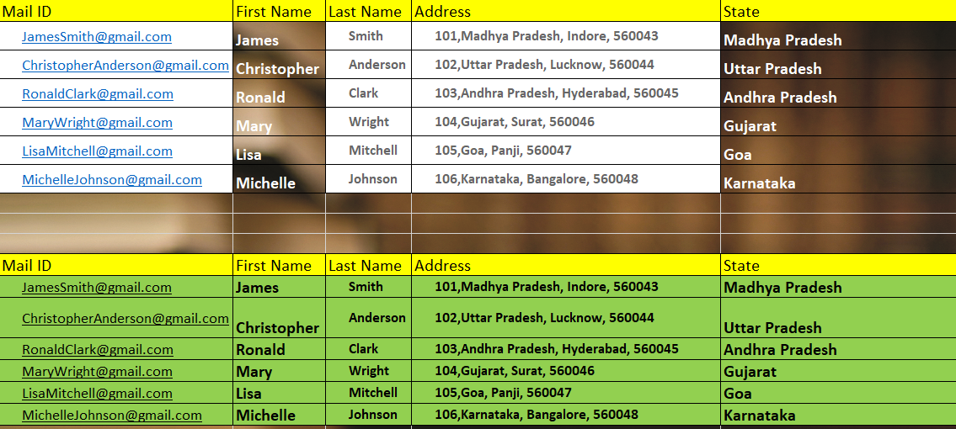

1. **What is freeze panes and why do we use freeze panes? Give examples.**

Answer – It means while choosing this option it freezes the rows and columns when select the row below the last row you want frozen and right of the column you want to be frozen and click Freeze panes. 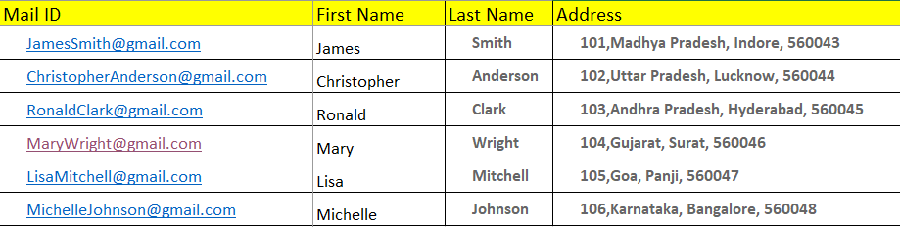 # The complete data.# Data after using Freeze Pane.

1. **What are the different features available within the Freeze Panes command?**

Answer – There are three features with freeze panes,

1. Freeze Pane – Select the row below and right column of the data which we want to freeze.
2. Freeze Top Row – It Freezes the top row of the worksheet.
3. Freeze First Column – It Freezes the first column of the worksheet.



5**. Explain what the different sheet options present in excel are and what they do?**

Answer – By default when we open excel there is only one sheet, but we can add as many as we want, and another sheet option is Protect sheet which protects the sheet from editing or deleting any data.